Hive Mini Project-2

*Consider for 500 columns*

PART-1:Examine the Data

1.Find the total number of tickets for the year.

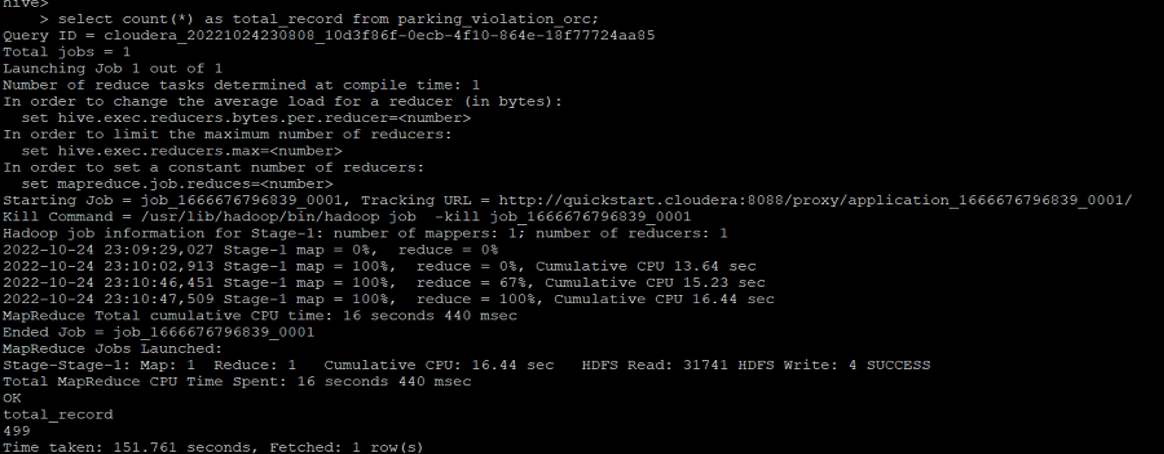

2.Find out how many unique states the cars which got parking tickets came from.

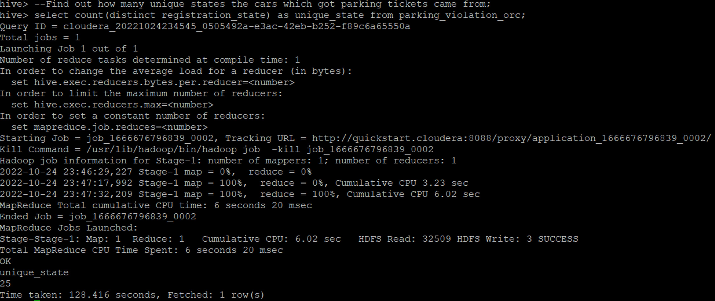

3.Some parking tickets don’t have addresses on them, which is cause for concern. Find out how many such tickets there are(i.e. tickets where either "Street Code 1" or "Street Code 2" or "Street Code 3" is empty )

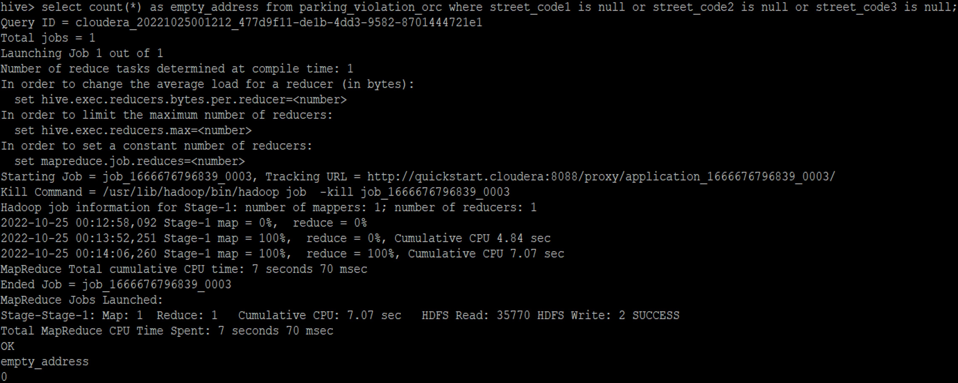

PART -2 Aggregation tasks

1.How often does each violation code occur? (frequency of violation codes - find the top 5)

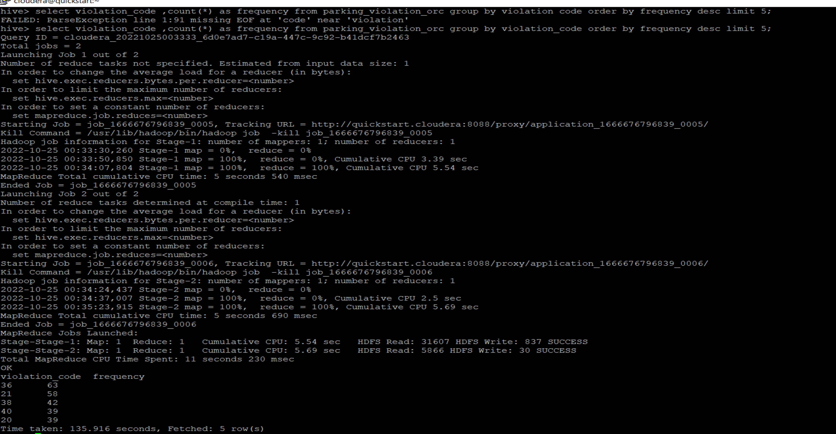

2.1 How often does each vehicle body type get a parking ticket? How about the vehicle make? (find the top 5 for both)

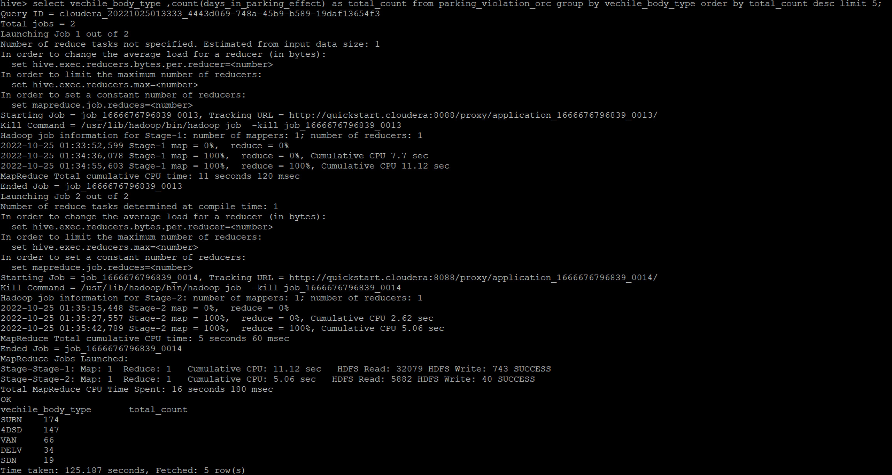

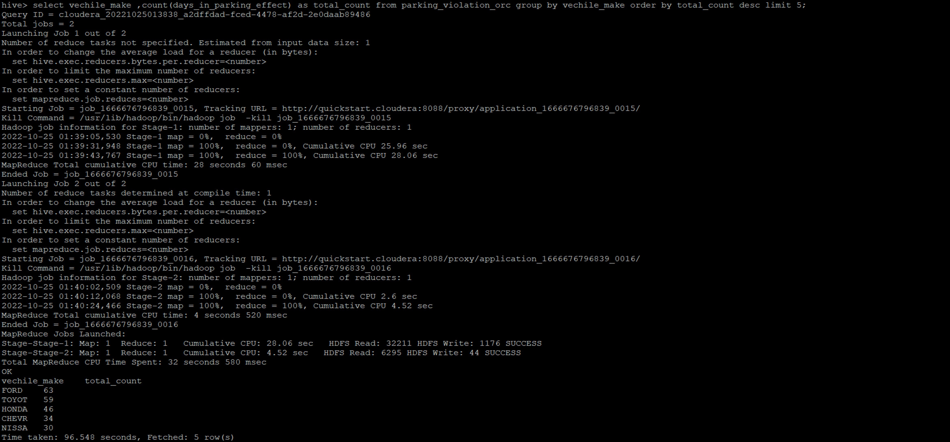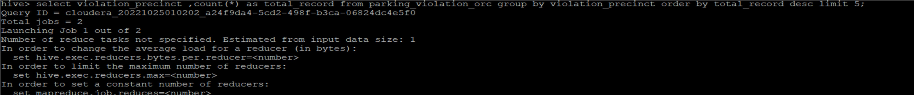2.2 How about the vehicle make?

3.A precinct is a police station that has a certain zone of the city under its command. Find the (5 highest) frequencies of:

1. Violating Precincts (this is the precinct of the zone where the violation occurred)
2. 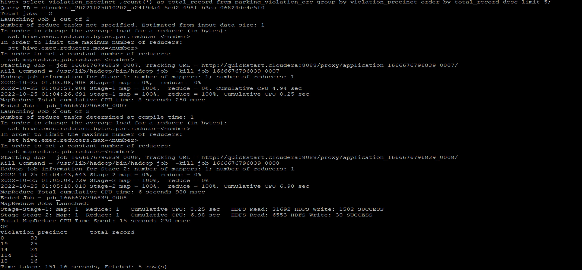Issuer Precincts (this is the precinct that issued the ticket)

